PWGSC Open Data Tool

User Guide

Version 6.4
April 27, 2017

Contents
PWGSC Open Data Tool 1
User Guide 1
Contents 2
Introduction 4
Tool Limitations 4
Installation 4
System Requirements 4
Installing the WPSS Open Data Tool 5
Uninstall 5
Uninstalling Perl 5
Uninstalling Python 6
Using the WPSS Open Data Tool 7
Open Data Tab 7
Description URL 8
Dictionary Files 9
Data Files 9
Resource Files 9
Configuration Tab 9
Profiles 11
Results Window 12
Stopping the Analysis 13
Reporting Passes and Fails 13
Saving Results 13
Command Line Interface 14
Status and Progress 14
Language Switching 14
Troubleshooting 15
Perl Command Line Interpreter Error 15
500 Internal Server Error 15
Test Cases 17
OD_URL - Open data URL 17
Checks performed 17
Does not check 17
OD_ENC - Character encoding 17
Checks performed 17
OD_VAL – Validation 17
Checks performed 18
OD_DATA – Data Quality 19
Checks performed 19
TP_PW_OD_BOM – UTF-8 BOM 20
Checks performed 20
TP_PW_OD_DATA – PWGSC Data Quality 20
Checks performed 20
TP_PW_OD_DD – Data Dictionary 21
Checks performed 21

Introduction
The PWGSC WPSS Open Data Tool provides a method to perform tests on datasets and dictionaries being submitted for the Open Data Registry to ensure they are compliant with Open Data standards. The WPSS Open Data Tool reviews all of the documents and analyses each one for compliance to standards.

Tool Limitations
Some of the output of the Open Data Tool is in English only. The tool is using third party software components. The source of these components is available only in the language that it was authored.

Installation
The WPSS Open Data Tool requires a Perl distribution installed on the workstation, and .pl files are associated with the Perl interpreter. The WPSS Open Data Tool has been tested with Strawberry Perl 5.18.1 (32 bit). Other versions of Strawberry Perl, or other Perl installations may not work as expected or may be missing required modules.

System Requirements
- Microsoft Windows 7 (or later)
- Java runtime environment 1.8.0 (other versions may not work),
- Python version 2.7.6,
- Strawberry Perl 5.18.1 (32 bit),
- Only one installation of Perl on the system. Multiple installations may cause problems.
If you do not have the Perl or Python, you will need to install them manually. You can find installations at:
- Python 2.7.6 available from http://python.org/ftp/python/2.7.6/python-2.7.6.msi
- Strawberry Perl 5.18 (32 bit) available from http://strawberry-perl.googlecode.com/files/strawberry-perl-5.18.1.1-32bit.msi
For the Perl and Python installs, accept the default settings during the installation process.

Installing the WPSS Open Data Tool
To install the WPSS Open Data Tool, double-click the WPSS_Install.exe file and follow the instructions on the screen.
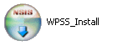
The default installation folder for the WPSS Validation Tool is C:\Program Files\WPSS_Tool.

Uninstall
To remove the WPSS Open Data Tool from a workstation, run the uninstall script.
To uninstall the Open Data Tool:
Go to Start > Programs > WPSS_Tool > Uninstall.
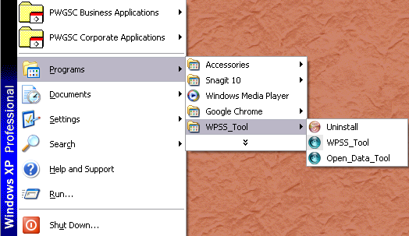

Uninstalling Perl
To remove the Perl installation:
- Go to Start > Settings > Control Panel.
- Click Add or Remove Programs.
- Locate the Strawberry or ActivePerl installation and click Remove.

Uninstalling Python
To remove the Perl installation:
- Go to Start > Settings > Control Panel.
- Click Add or Remove Programs.
- Locate the Python installation and click Remove.

Using the WPSS Open Data Tool
To start the PWGSC WPSS Open Data Tool:
- Go to Start > Programs > Web and Open Data Validator.
- Click the Open Data Tool icon.
Alternatively, using Windows Explorer, navigate to the C:\Program Files\WPSS_Tool folder and double click the open_data_tool.pl file.
The main window consists of two tabs:
- Open Data is for entering the dictionary, data and resource file references for analysis.
- Configuration is for configuring the WPSS Open Data Tool profile.

Open Data Tab
To analyse the documents identified for the Open Data Registry, enter the URLs for the dictionary, data and resource files into the WPSS Open Data Tool. Use the Open Data tab to enter this information.
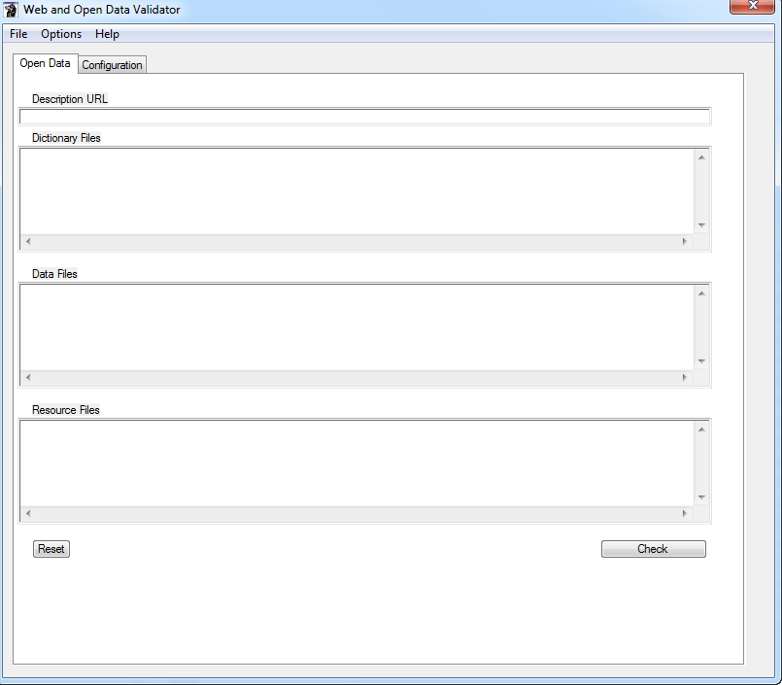

Description URL
The URL to a JSON object that describes the dataset details (e.g. dictionary file, data files, etc.). A link to the JSON object can be found on the dataset details page on the http://open.canaca.ca site (e.g. http://open.canada.ca/data/en/dataset/5ea9438d-07ea-4ae0-a9b9-e36df2089899 ). The link appears below the About this Record right hand menu in a link labelled “Link to JSON format”

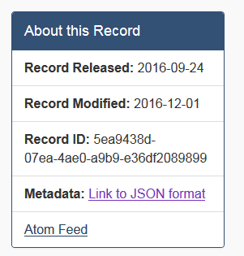

Dictionary Files
The list of URLs for data dictionary files.

Data Files
The list of URLs for data files (e.g. CSV).

Resource Files
The list of URLs for dataset resource files (e.g. supporting documentation).

Configuration Tab
The Configuration tab enables you to select the option for the analysis.
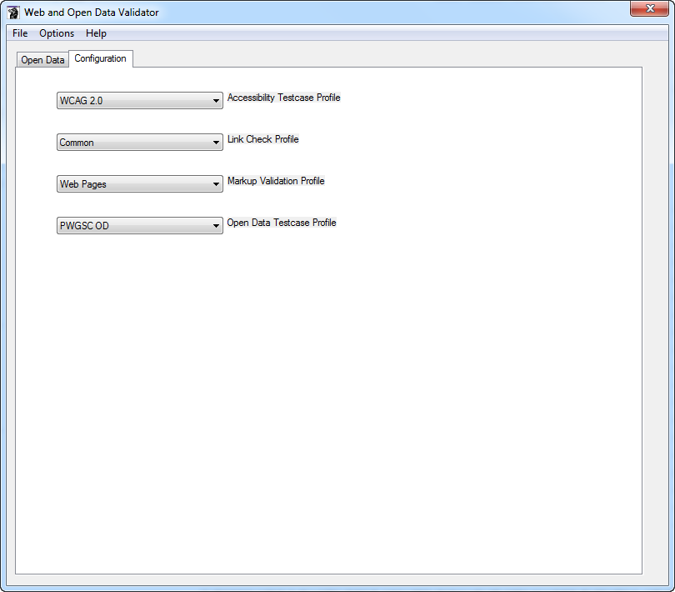

Accessibility Testcase Profile – Controls the Web Accessibility tests that are performed on any HTML supporting files that are part of the dataset. Options include:
- WCAG 2.0 – WCAG 2.0 A and AA checks
- None – no accessibility checking

Link Check Profile – Controls the link checking that is performed on any supporting files that are part of the dataset. Options include:
- Common – Broken links, cross language links
- All – all link violations
- Errors – report broken links only
- IPV4 – report IP addresses used as domain names
- None

Markup Validation Profile – Controls the markup validation that is performed on any supporting files that are part of the dataset. This option does not affect the markup validation of data files. Options include:
- Web Pages – only web pages are validated, does not include supporting files such as CSS, JavaScript
- All – all files
- None – no validation of supporting files.

Open Data Testcase Profile – Controls the set of checks performed on data dictionary and data files in the dataset. Options include:
- PWGSC OD – PWGSC specific checks as well as all common checks
- Common – TBS and best practise checks
- None – No open data checks

Profiles
You can save the open data details in a configuration profile for sharing, or easy access if you want to use the WPSS Open Data Tool again.
To save the data profile:
- Go to File > Save Open Data Config.
- Select a folder and file name for the configuration file.
- Click OK.
To best manage the configuration files, it is suggested that you save the configuration files to the C:\Program Files\WPSS_Tool\profiles folder.
You can load a previously saved site configuration. Loading a saved configuration file loads the Open Data tab fields. Once loaded, you can modify the information if required.
To open a saved profile:
- Go to File > Load Open Data Config.
- Locate the folder and file.
- Click OK.

Results Window
The Results Window includes three tabs containing the output of an individual analysis from the WPSS Open Data Tool. The output in each tab includes a header that lists information and the time and date when the analysis started.
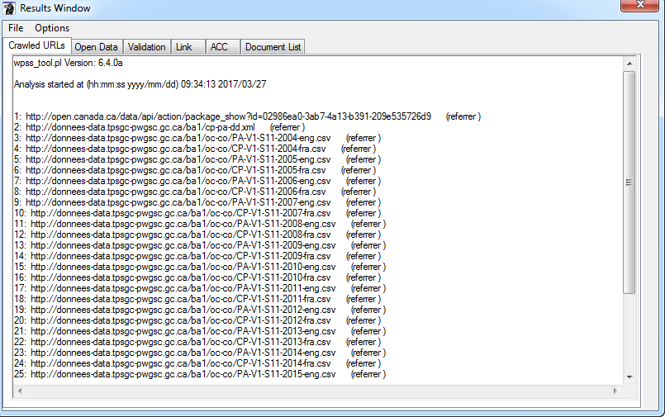
Crawled URLs tab – Provides a list of the URLs the WPSS Open Data Tool analysed. It lists the referrer page to indicate how the crawler reached a particular page. Use this tab to monitor the WPSS Open Data Tool to ensure it is actively crawling and analysing the files.
Open Data tab – Lists the documents that contain open data check violations.
Validation tab – Contains the output of the HTML/XHTML, CSS and robots.txt validation tools.
Link tab – Lists the link violations found in HTML supporting files.
ACC tab – Contains the output of the accessibility check.
Document List tab – The Open Data Tool writes information to this tab after completing the site analysis. It contains the sorted list of files reviewed.
The WPSS Open Data Tool includes the time and date at the end of the report in each tab.

Stopping the Analysis
If you need to stop the analysis while it is running, in the Results Window, go to Options > Stop Crawl. This stops the WPSS Open Data Tool after processing the current document. The results include a note at the bottom of each output tab in the Results Window indicating that the analysis was aborted.

Reporting Passes and Fails
The default behaviour of the analysis tools is to report only URLs that fail checks. You can view results for both passes and fails. To see both passes and fails, in the WPSS Open Data Tool window, go to Options > Report Fails and Passes. The URL for documents that pass checks are recorded in the results output.
To see only failed pages, go to Options > Report Fails Only.

Saving Results
To save the analysis results, in the Results Window, go to File > Save As. Select the file name and folder path in the file chooser dialog box. The results are stored in a number of files, one for each result tab. Each file name contains a suffix identifying the report type.
For example, you save the results in the file od_results, the actual files are:
- od_results_acc.txt
- od_results_crawl.txt
- od_results_od.txt
- od_results_urls.txt
- od_results_val.txt
There will be 2 additional CSV files created, one being a detailed listing of all the dataset file URLs and the other is a CSV version of the test case results.
- od_results_file_inventory.csv
- od_results_rslts.csv
It is suggested that you use the same name for the results as the open data profile name, and save the results in the \WPSS_Tool folder.

Command Line Interface
The WPSS Open Data Tool is available from the GUI interface and from the command prompt.
To access the command line version:
- Go to Start > Programs > Accessories > Command Prompt.
- Change to the Program Files\WPSS_Tool directory.
- Run the program open_data_tool.pl with the command:
open_data_tool.pl –cli –o <profile file>
where <profile file> is the path to the profile file containing the details of the open data to be analysed.

Status and Progress
As the command line WPSS Open Data Tool runs and analyses documents, the URLs of the documents appear in the console window. Use this to monitor the WPSS Open Data Tool to ensure it is actively crawling and analysing the data files.

Language Switching
You can toggle the language of the analysis results using a command line option.
Option | Result
-eng | Analysis results are provided in English.
-fra | Analysis results are provided in French.
If no language selection is made, the language is determined from the operating system.

Troubleshooting

Perl Command Line Interpreter Error
The WPSS Open Data Tool uses a number of Perl modules. These modules may have errors that cause the program to fail. You may encounter the following message:
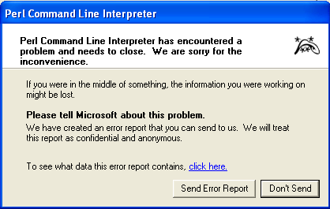
Message | Perl Command Line Interpreter has encountered a problem and needs to close.
Cause | An error in the supporting Perl modules.
Correction | Restart the WPSS Open Data Tool; if the problem persists send an email to PlanificationWeb-WebPlanning@tpsgc-pwgsc.gc.ca.

500 Internal Server Error
When analysing data, the WPSS Open Data Tool may report a “500 Internal server error”. This may be due to a limitation on the Web server and not the WPSS Open Data Tool. The problem may be due to the Web server not handling the “Range” setting in the HTTP GET operation. The WPSS Open Data Tool sets a size limit on GET operations to avoid getting extremely large documents.
To avoid this error, you can change the WPSS Open Data Tool configuration file setting to not include the “Range” setting in a HTTP GET operation.
Using a simple text file editor, such as WordPad:
- Open the file c:\Program Files\wpss_tool\conf\wpss_tool.config.
- Locate the following lines in the file:
#
# Max User Agent Size limits the size of files accepted in a GET
# request. A value of 0 means we can accept documents of any size.
# A value of 0 also removes the Range field from the HTTP header.
#
#User_Agent_Max_Size 0
- Remove the leading ‘#’ character from the #User_Agent_Max_Size 0.
This functionality is not available through the user interface, only by directly editing the configuration file.

Test Cases
This section describes the criteria the Open Data Tool uses to verify the syntax and content of Open Data dataset files.

OD_URL - Open data URL
Check URLs of the open data files.

Checks performed
- That the dataset file (dictionary, data and resource) exists.
- Checks that the mime-type and file suffix are consistent (e.g. a .csv file has a mime type of text/csv or text/x-comma-separated-values).
- That there is the same number of language specific data files in a dataset.

Does not check
- That the dataset file is available to the public. For example, available on the Internet.

OD_ENC - Character encoding
Check the character encoding used in files.

Checks performed
- That the content of the dataset files is UTF-8 encoded.
- Checks XML files to ensure the ‘encoding’ attribute of the <xml> tag specifies UTF-8 encoding.
- Check that all JSON files specify a charset in the HTTP::Response or contain a UTF-8 BOM (Byte Order Mark) at the beginning of the file.

OD_VAL – Validation
Check validity of content mark-up or syntax.

Checks performed
All file types:
- That the file has content.

CSV files:
- That CSV data files are well formed, properly delimited and quoted.
- That CSV files conform to Common Format and MIME Type for Comma-Separated Values (CSV) Files (RFC-4180)

JSON files:
- That JSON files are well formed.
- That the JSON file contains a $schema name/value pair to specify the schema.
- If the file contains a $schema name/value pair, it checks that the JSON content conforms to that schema.

XML Files:
- That the file is well formed with properly nested and closed tags.
- That the file includes either a DOCTYPE of Schema specification.
- If the file includes an ‘xsi:schemaLocation’ attribute or xsi:noNamespaceSchemaLocation attribute to specify a schema, it checks that the XML file conforms to that schema.
- If the file includes a DOCTYPE tag, it checks that the XML file conforms to that doctype.

ZIP Files:
- That the ZIP file is a valid ZIP archive.

JSON Dataset Description Files:
- That required fields are in the JSON dataset description file.

OD_DATA – Data Quality
Data Quality checks.

Checks performed
All Files:
- If there is a data dictionary, and the data dictionary specifies a regular expression for data values, then check that the data value matches the expression.

CSV Files:
- That CSV data files have the same number of fields in each row.
- There is data in each row (i.e. the row does not have only empty fields).
- There are no duplicate rows (i.e. the same data in 2 rows).
- There are no duplicate columns of data (i.e. the same data in 2 columns). Duplicate columns of empty fields or fields containing a 0 (zero) are allowed.
- There are no duplicate column headings.
- If there is a data dictionary, and the data dictionary specifies a data pattern, then check that the data value matches the pattern.
- If there is a data dictionary, and the data dictionary specifies a data condition (defined by CSV Schema 1.0), then check that the data value matches the condition.
- If the first line of a multi-line field contains whitespace only.
- Text fields for possible WCAG 2.0 plain text technique accessibility errors (e.g. lists in cells).
- Check that column types (e.g. numeric, text) match for all language variations of the same data file.
- Check that the sum of the values for numeric data columns match for all language variations of the same data file.
- Check that the number of non-blank cells in each column matches for all language variations of the same data file.

JSON-CSV Files (JSON encoded CSV files):
- Check there is a CSV data file for each JSON-CSV data file.
- Check that the number of JSON-CSV data array items matches the number of data rows in the corresponding CSV data file.
- Check that language variants of JSON-CSV data files have the same number of fields in each data array item.
- Check that there are no duplicate data array items (i.e. the same data in 2 array items).
- If there is a data dictionary, and the data dictionary specifies a data pattern, then check that the data value matches the pattern.

TP_PW_OD_BOM – UTF-8 BOM
UTF-8 Byte Order Mark.

Checks performed
- Check that all CSV and TXT files contain a UTF-8 BOM (Byte Order Mark) at the beginning of the file.

TP_PW_OD_DATA – PWGSC Data Quality
PWGSC data quality checks.

Checks performed
All Files:
- If the file is uncompressed it does not exceed the maximum size limit (default 50 Mb).
- If there are language specific variations of a data file, that required languages (i.e. English, French) variations exist.

CSV Files:
- The CSV data files must have a header row.
- If at least 25% of the fields on the first row matches the data dictionary terms, then checks to see if all fields match dictionary terms.

JSON Dataset Description Files:
- The JSON content is a valid open.canada.ca JSON dataset description.
- There is at least 1 data dictionary specified.
- There is at least 1 data file specified.
- If there are language specific data files, that all required languages (e.g. English, French) are found.

Zip Files:
- The ZIP archive contains only 1 type of file (e.g. all CSV or all XML).

TP_PW_OD_DD – Data Dictionary
PWGSC data dictionary file.

Checks performed
XML Data Dictionaries
- That XML data dictionaries follow the PWGSC XML Data Dictionary specification.
- That there are no duplicate headings.
- That there are no duplicate definitions.
- That definitions are provided for both official languages.

